WEB QUEST EDU 5375
Los Países Hispanos

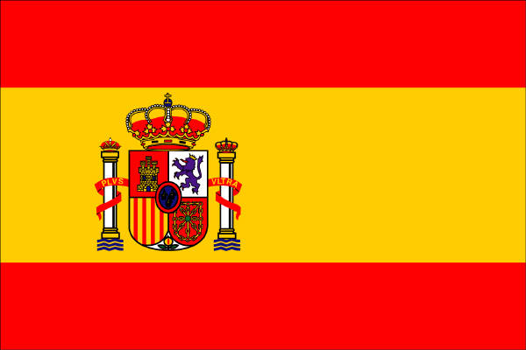
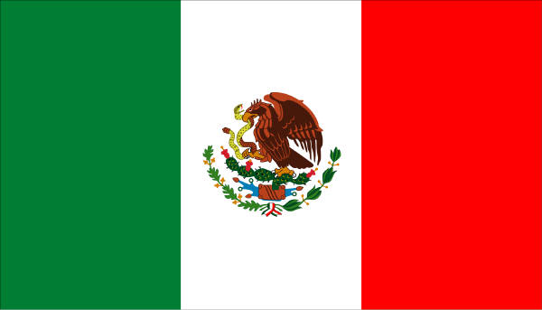

Introduction:
Congratulations! You and three other students have been selected to go on a trip to Spain or Mexico during your spring break. On your return you will be writing about your adventures for the student newspaper, as well as creating a country’s brochure. You will have the opportunity to choose which country you will visit and what you will do while you are there. Since your time is limited, you will need to choose an itinerary that will let you explore the best cultural, historical, shopping and entertainment opportunities the country has to offer. ¡Buen Viaje!
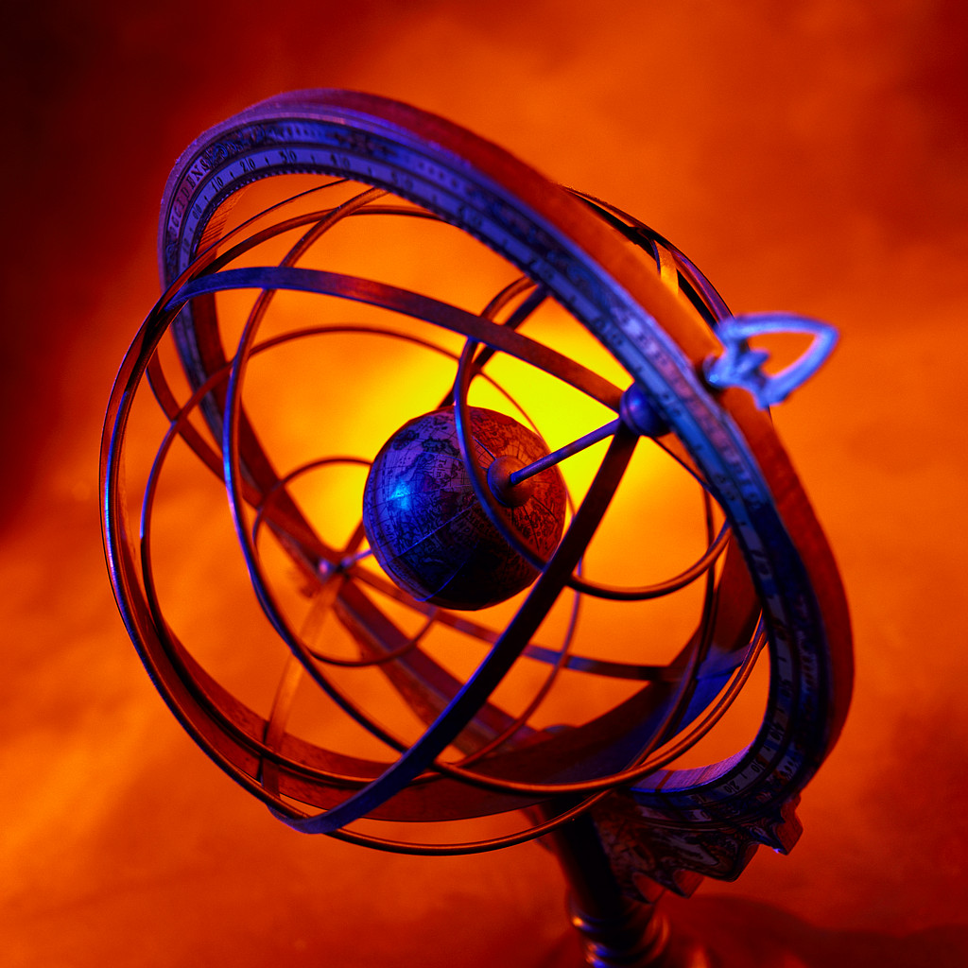

Task:
- As a group, narrow your choice to one country that interests you. If you think the country is large, you may also need to select a specific area of that country. (Ex: México - choose one of the states, like Puebla, Zapotecas, Oaxaca; España- Madrid, Barcelona etc.) Then choose the city or cities you will visit.
- Go to the sites listed below and explore. Take notes so you can keep track of the information you have found.
- After you have gathered all the required information, create the travel brochure. Be sure to include all important information about the country.
Guidelines
1. Make your brochure eye catching as well as informative.
2. Keep information user friendly - create a desire to come and explore the many facets of your country.
3. The final product must be typed/word processed.
4. Your brochure should include appropriate pictures or graphics to enhance your presentation.
5. Equally divide the workload among the team members. Everyone must be involved in the research and development process. Each person should be responsible for 4 categories.
6. Each person should find and choose at least 1 picture or graphic for each of the four sections they are covering.
7. Complete source log sheets and a working bibliography page for all resources used.
8. You cannot download all information found at a site. You can copy and paste appropriate information onto your Word file for rewriting.
9. Final print copy should be in your own words.
10. Complete role sheets for each person. Write brief journal entry as to what each person does each day.

Roles:
First of all, you will need to divide up the work so no one has to do too much. Here's a list of what each club officer needs to do:
- Student Uno: will make the travel arrangements and take care of the travel logistics such as how to get a passport, what the local currency and current rate of exchange is, and if there are any time zone changes.
- Student Dos: to find out about the geography and climate and provide a basic "what to pack" list so everyone will know what type of clothing and other gear to bring.
- Student Tres: is in charge of choosing shopping and entertainment activities, including souvenir suggestions based on the specialties of that country.
- Student Cuatro: is responsible for researching the historical and cultural sites of the country and choosing the specific places you will visit on your trip.

Process
For your team's country assignment, create a colorful, informative and dazzling brochure that will appeal to a variety of people which includes:
1. Country overview. Brief summary of the country with highlights
2. Climate and weather conditions for various times of the year.
3. Accommodations from hotels to campgrounds & Transportation
4. Arts & Culture from museums to theaters to Science and Nature
5. Food from fancy restaurants to food stalls on the street
6. Outdoor Recreation (from sports to parks and beaches) and Entertainment
7. Historic Sites
8. Map showing sites to visit
9. Shopping (best buys for this country)
10. Insider Travel Tips
11. Travel Advisory
12. Pictures/Graphics

Resources:
Spain
- Student One:
  - Passport Information
  - World Time Zones
  - Currency Exchange Rate / Universal Currency Coonverter
  - Places to Stay / Information on Accomodations
- Student Two:
  - Customs
  - Weather & Climate
  - General Information
  - Travel Information
- Student Three:
  - Area Specialties
  - Places to Go
  - Shopping
  - Things to Do
- Student Four:
  - History & Culture
  - Things to Do
  - Photo Tour
  - Things to See
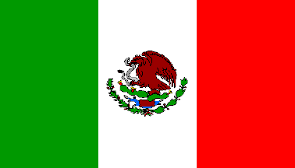Mexico
- Student One:
  - Passport Information
  - World Time Zones
  - Currency Exchange Rate / Universal Currency Coonverter
  - Places to Stay
- Student Two:
  - Weather Information
  - Cultural Information
  - Beaches
  - Travel Information
- Student Tree:
  - Area Attractions
  - Places to Go
  - What to Do
  - Souvenirs
- Student Four:
  - Mexican Adventures
  - Archaeological Destinations
  - What to Do
  - What to See

Conclusion
By researching this country, doing the travel plan, and creating the brochure you have a deeper understanding of your Spanish-speaking country and have also learned how to use sites and search tools. You should also now be able to use this experience and knowledge to gain information for other projects and to teach other students how to access information using the Internet.
After you have designed your travel brochure, think about the following questions and answer them individually on white lined paper. Your responses will be collected.
- How does your travel brochure compare with real brochures of your country? How are they similar and different?
- Based upon what you have learned, would you visit your country? Why or why not?
- What information presented sparked your curiosity and possibly a desire to visit your country?
- What information did you think was unimportant to making travel plans to this country? What information, if any, would you add?
- How can this experience help you plan a vacation in the future?

Web Quest Rubric
 | Beginning  1 | Developing  2 | Accomplished  3 | Exemplary  4 | Score
Group Participation
Accuracy of Information
Depth of Information
Design of Brochure

