Proyecto de Cultura
7o. Grado
Sra. Rak

You will become the ambassador of one Hipanic Country:
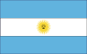  Argentina | 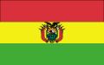  Bolivia | 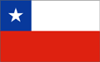  Chile
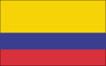  Colombia | 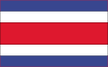  Costa Rica | 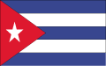  Cuba
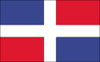  Dominican Republic | 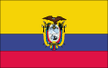  Ecuador | 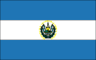  El Salvador
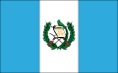  Guatemala | 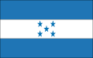  Honduras | 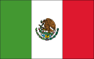  Mexico
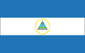  Nicaragua | 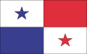  Panama | 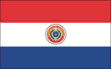  Paraguay
  Peru | 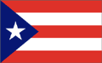  Puerto Rico | 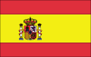  Spain
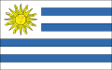  Uruguay | 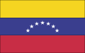  Venezuela

Objetivos:
- Students will familiarize themselves with a Spanish speaking country, and its culture as they research information from that country.
- Students will become more proficient at researching on the web, multitasking, incorporating photos and text and creating a visually stimulating and informative presentation.

*Once you have selected the country you want to base your project on, you will choose one of the following five options:
- Brochure – depicting major information about the country: tourist places, industries, location, society, culture, holiday, celebrations, pictures, etc.
Microsoft Word
http://www.mybrochuremaker.com/
http://en.wikipedia.org/wiki/Brochure

- Menu – should include soups or salads, appetizers, main dishes, desserts and drinks, along with pictures and prices in the currency or the country.
http://www.lasculturas.com/lib/libFood.htm
http://www.foodservicedirect.com/index.cfm/S/412/Hispanic_Food.htm
http://www.carnegielibrary.org/subject/food/latin.html
http://www.ma.iup.edu/Pueblo/latino_cultures/recipes.html

- Dish – research and prepare a dish, explain the process, and share it with the class.
http://www.lasculturas.com/lib/libFood.htm
http://www.foodservicedirect.com/index.cfm/S/412/Hispanic_Food.htm
http://www.carnegielibrary.org/subject/food/latin.html
http://www.ma.iup.edu/Pueblo/latino_cultures/recipes.html

- Famous Person – investigate a famous person who has also contributed to a humanitarian cause in his/her country or the US.
http://www.emints.org/ethemes/resources/S00001570.shtml

http://www.mcps.k12.md.us/schools/wjhs/mediactr/forlangpathfinder/famhisp4/famhis4.html

http://www.adventureonline.com

- Representative Object – Create an artifact that is representative of the culture of one of the Hispanic countries: a piñata, a sombrero, a shawl, maracas, etc.
http://www.espanole.org/pais
http://www.colloquio.com
http://www.oas.org/children

*After selecting the country and completing the project, prepare a one page report describing your project, the reason for selecting it, and a reflection of the process and final product.
Important Dates Completed
Select a topic and a country by December 11, 2006.
Start reading about it, research using the school library and the Internet (as well as at home)
Separate pictures from Internet sites
Work on the project
Use the school resources on 12/11/06. Start formatting the project.
Start writing the rough draft. Hand in for first revision 12/20/06.
Continue revising, adding, deleting material.
Finalize project formatting
Hand in written document by January 2nd. Keep a copy.
Presentations of projects to class on 1/ /07

